# Part 1

Firstly we must break the transfer function G(s) into parts to approximate low/high frequency performance and the break frequency.

$$G\left(s\right)=\frac{1}{s+16} \\ G\left(s\right)=\frac{1}{16}×\frac{16}{s+16}$$

The constant component has a gain of:

$20\log_{10}{\frac{1}{16}}=-24.08dB$ At all frequencies.

The first order component has a gain of 0dB at low frequency, and can be approximated after a break frequency as a straight line. $$\frac{16}{s+16} break frequency of \frac{16rad}{s} \\ ∴-\frac{20db}{decade} where 16<ω$$

The Phase change due to this first order component is given by $$∴-\frac{-45 degrees}{decade} where 1.6<ω<160$$

These approximated Gain and Frequency bode plots can be seen on the following page (Error: gain was meant to start at -24dB, not -55 as seen in plot). The actual Gain and Frequency Plots from MATLAB software analysis is shown below.

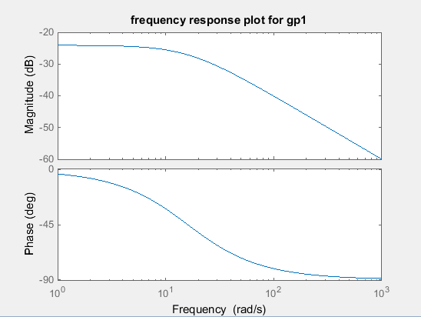

For low and high frequencies, the approximated bode plot is very similar to the actual values for gain and frequency. The difference between the approximated and actual plots mainly lies around the break frequency, where the gain smoothly transitions into a straight line, and the frequency is a wave rather than the approximate straight line. After 160rad/s however the two plots are very similar.



# Part 2

Breaking G(s) into components to approximate high/low frequency performance and break frequency

$$G\left(s\right)=\frac{1}{s^{2}+5.66s+16} \\ G\left(s\right)=\frac{1}{16}×\frac{16}{s^{2}+5.66s+16}$$

The constant component has a gain of:

$$20\log_{10}{\frac{1}{16}}=-24.08dB$$ at all frequencies

The second order component has a gain of 0dB at low frequency, and can be approximated after a break frequency as a straight line. $$\frac{16}{s^{2}+5.66s+16} break frequency of \frac{16rad}{s} \\ ∴-\frac{40db}{decade} where 16<ω$$

The Phase change due to this second order component is given by $$∴-\frac{-90 degrees}{decade} where 1.6<ω<160$$ 
These approximated Gain and Frequency bode plots can be seen on the following page (Error: gain was meant to start at -24dB, not -55 as seen in plot). The actual Gain and Frequency Plots from MATLAB software analysis is shown below.

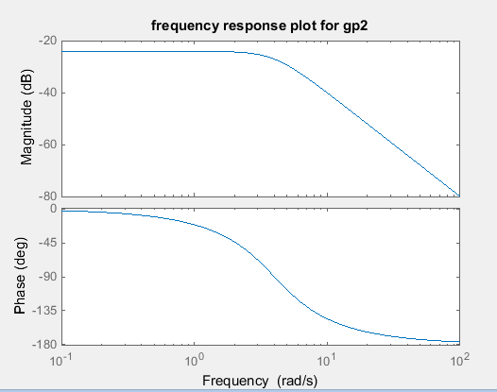

The differences between this actual plot and the approximate plot are the same as seen in Part 1. The difference between this system and the previous one however is that this is a second order system. The gain and phase decreases much faster than a first order does as the frequency is increased. The phase change is also double that of a first order system (-180 from -90).



# Part 3

Simulink Plots to verify above plots:

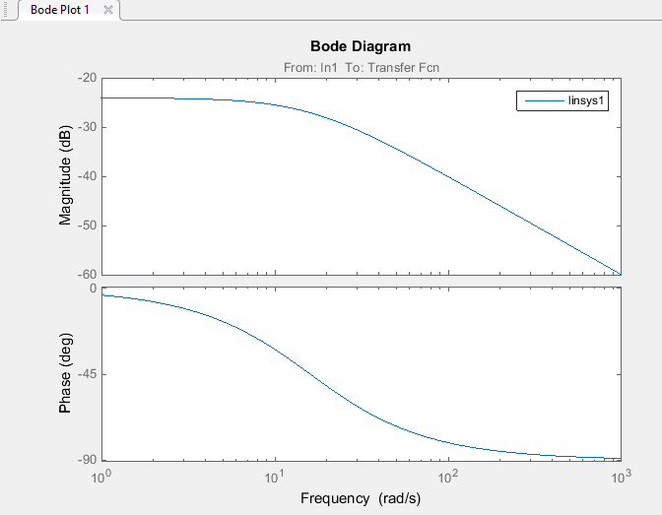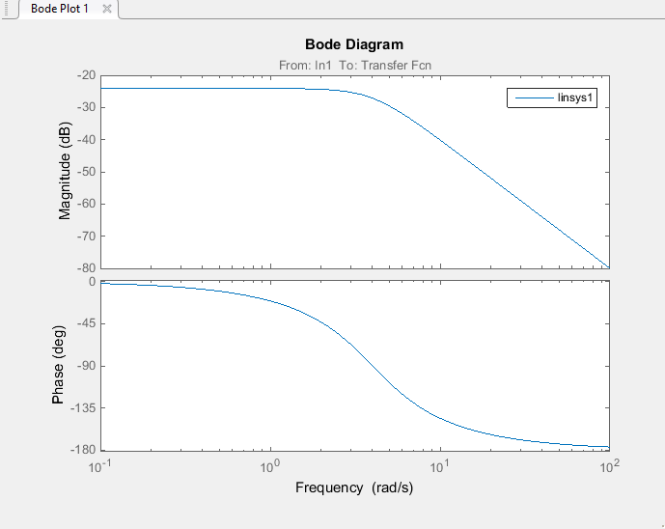

# Part 4

Assuming that G(s) is the feed forward transfer function of a unity feedback system:

$$G\left(s\right)=\frac{1}{s+16}$$

The total Transfer function is given by TF(s) $$TF\left(s\right)=\frac{G\left(s\right)}{1+G\left(s\right)} \\ TF\left(s\right)=\frac{1}{s+16+1} \\ TF\left(s\right)=\frac{1}{s+17}$$

Using Simulink to plot this:

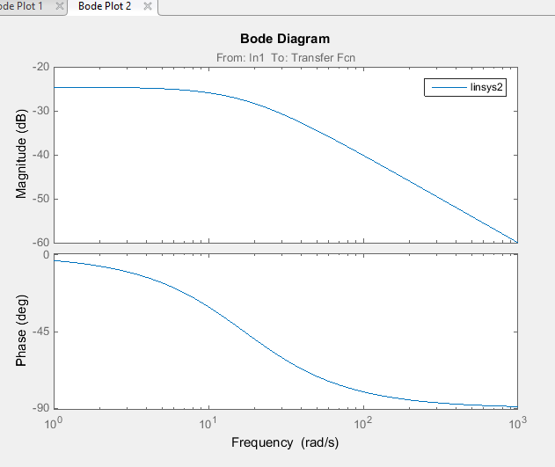

The differences between these gain and phase plots when compared to only the feedforward transfer function is that the break frequency is now at 17 rad/s from 16. The phase change of the system is still the same at low/high frequencies however the phase while around the break frequencies is offset slightly.

The Gain of the closed loop transfer function starts to linearize 1 rad/s later however the low frequency response has changed slightly. The new gain approximation for frequencies less than 17rad/s is:

$$20\log_{10}{\frac{1}{17}}=24.61dB$$

Thus offsetting the gain plot down by about 0.6dB.